**KGiSL Institute Of Technology**

**NAAN MUDHALVAN**

***Project Title*** *:*

## Air Quality Analysis In TN

***Team Members :***

1. Nimisha.p.s

2. Mirthika.s

3. Eben F Gabriel

4. Vigneshwaran.p

***Problem Definition:***

## Air Quality Analysis In TN

***Objectives:***

***Steps:***

IN GOOGLE COLAB NOTEBOOK:

• Mount the Google Drive

• Loading the Dataset to Google Drive

• Calculating mean of NO2, SO2, RSPM/PM10

• Plotting areas with high polluting level

***Calculating mean of NO2, SO2, RSPM/PM10 of each city:***

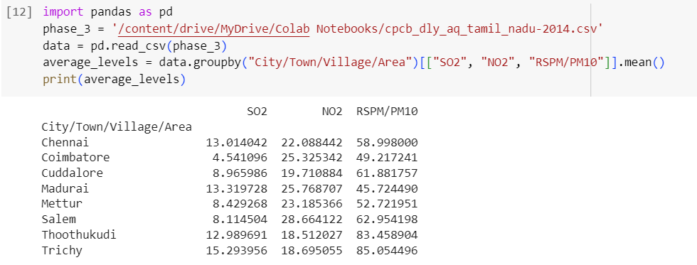

***Plotting the mean calculated:***

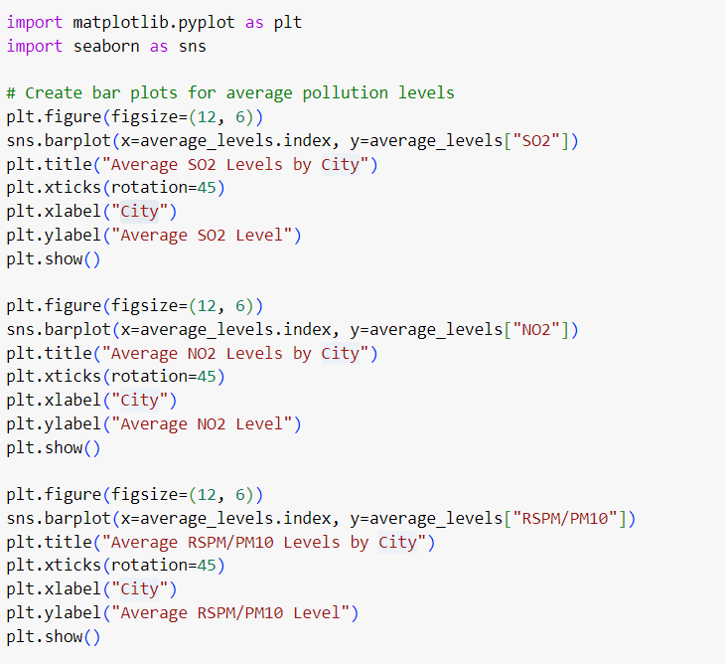

***Output:***

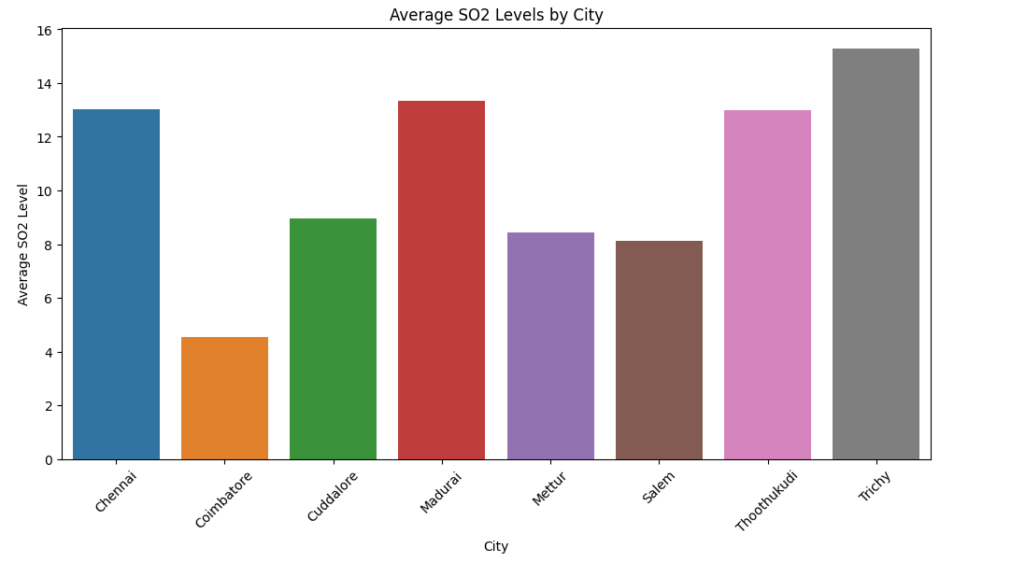

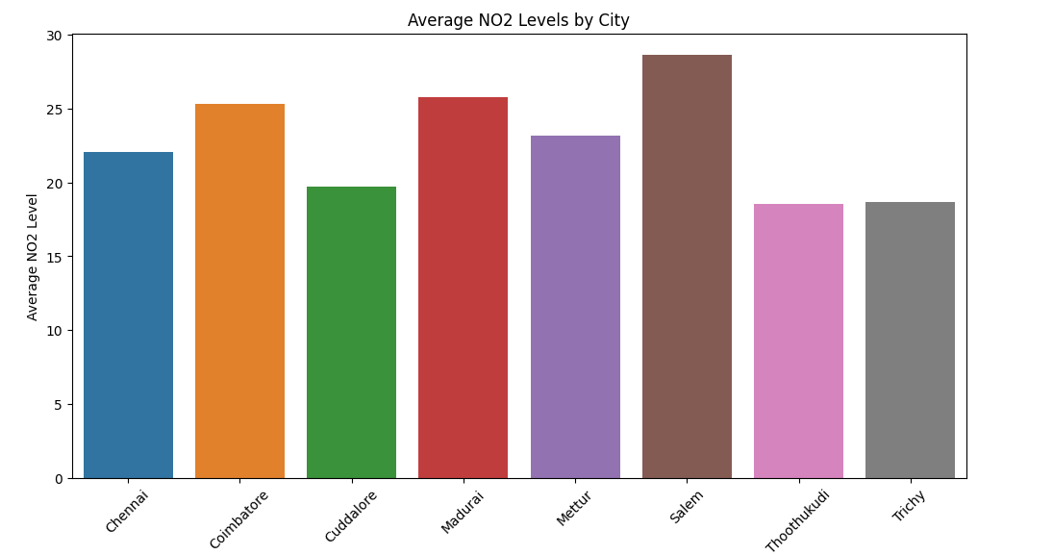

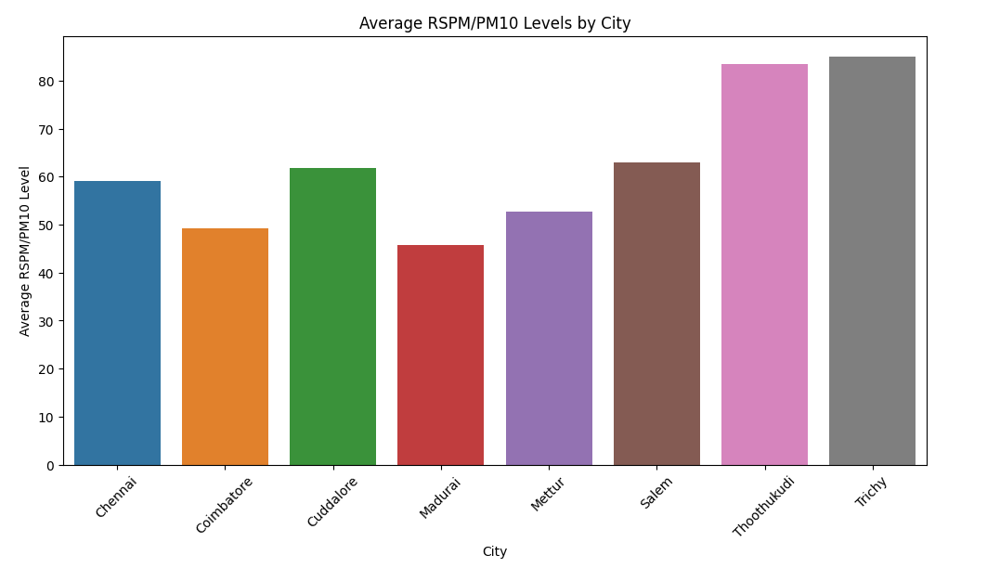

***Plotting graph for high polluting areas:***

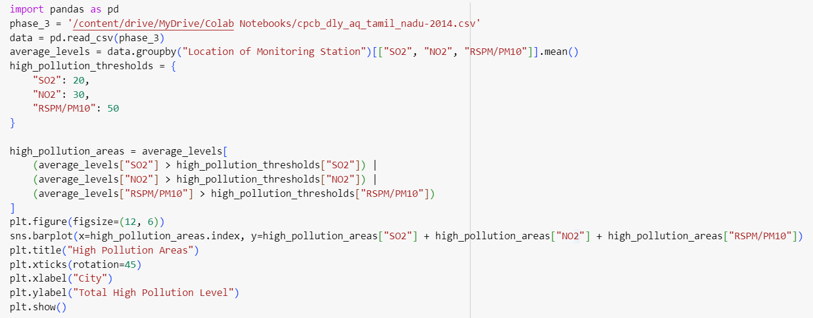

***Output:***

